Database Design Deliverables
ERD (Logical Schema) • Physical Schema • Normalization

1. ERD (Logical Schema)
Entity Relationship Diagram for the MediCare Clinic Management & Appointment System.
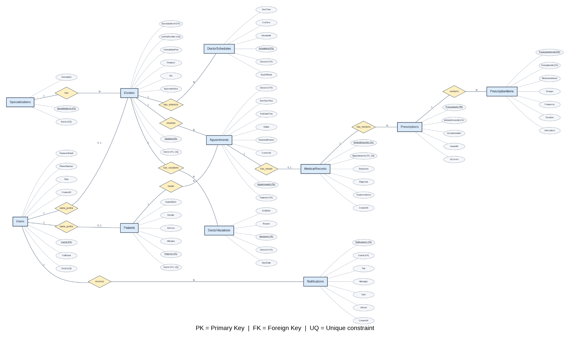

2. Physical Schema
Physical database schema showing tables, columns, data types, primary keys, and foreign keys.
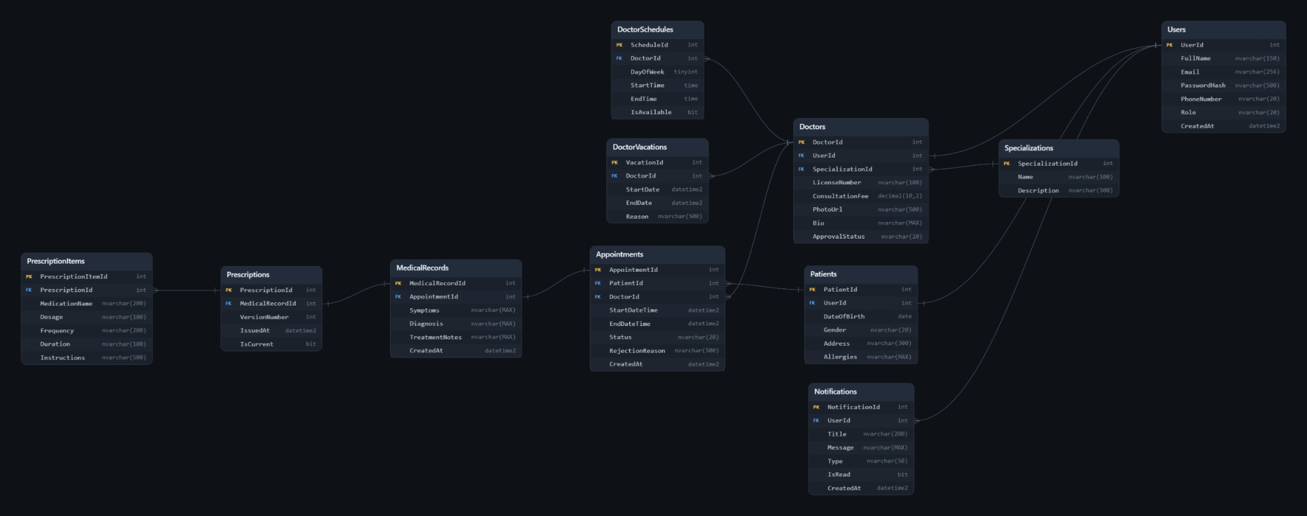

3. Normalization
Database Normalization Report
Clinic Management & Appointment System
Normalization review of the proposed 11-table schema

1. Introduction
Normalization is the process of organizing relational data into tables to reduce unnecessary duplication and prevent insertion, update, and deletion anomalies. This report reviews the proposed MediCare schema against the first three normal forms: 1NF, 2NF, and 3NF.

2. Current Schema Overview
The reviewed design contains 11 tables: Users, Patients, Doctors, Specializations, DoctorSchedules, DoctorVacations, Appointments, MedicalRecords, Prescriptions, PrescriptionItems, and Notifications.

3. First Normal Form (1NF)
Requirement: each field should contain a single value, and repeating groups should not be stored as multiple values in one column. Rows should be identifiable by a key.
Application to MediCare: the proposed design stores individual values in fields such as Users.Email, Appointments.StartDateTime, DoctorSchedules.StartTime, and PrescriptionItems.MedicationName. Medication details are represented as separate PrescriptionItems rows rather than a comma-separated list in a single field. The design is structured to satisfy 1NF, assuming the application stores one value per field.

4. Second Normal Form (2NF)
Requirement: the table must satisfy 1NF, and every non-key attribute must depend on the whole candidate key, not just part of it. This is especially relevant when a table uses a composite key.
Application to MediCare: each table uses a single-column primary key (for example, AppointmentId or PrescriptionItemId). The schema also has a unique constraint on (MedicalRecordId, VersionNumber) to identify a prescription version. No partial dependency is evident from the supplied schema. On the information available, the design is consistent with 2NF.

5. Third Normal Form (3NF)
Requirement: the table must satisfy 2NF, and non-key attributes should depend on the key, the whole key, and nothing but the key; non-key attributes should not depend transitively on other non-key attributes.
Application to MediCare: specialization names are stored in Specializations rather than repeated in Doctors; patient profile fields are separated from shared account fields in Users; doctor-specific fields are stored in Doctors; and medication lines are stored in PrescriptionItems. These separations reduce duplication and common update anomalies. Based on the listed columns and intended dependencies, the design appears consistent with 3NF. A formal proof would require confirming all functional dependencies and business rules.

6. Examples of Anomalies Avoided

7. Design Notes and Limitations
The report evaluates the simplified 11-table schema using Users as the shared account table. If standard ASP.NET Identity is used, the physical database may instead include AspNetUsers and additional role, claim, login, and token tables.
Role-based authorization is enforced by the application using ASP.NET Core / ASP.NET Identity. A Role column can represent a role in a simplified schema, but it does not by itself enforce page or data access.
The optional MedicalDocuments table is not included in the 11-table design. Add it only if document uploads are included in the implementation scope.
Normalization alone does not prevent overlapping appointments. Additional application/database logic and concurrency protection are required.
Rules such as EndDate >= StartDate and EndTime > StartTime should be enforced separately, for example through validation and database check constraints.

8. Conclusion
The MediCare schema separates user accounts, patient and doctor profiles, specializations, schedules, appointments, medical records, prescription versions, prescription items, and notifications into distinct related tables. This structure reduces unnecessary duplication and is consistent with the principles of 1NF, 2NF, and 3NF based on the current schema and intended functional dependencies. Before final submission, confirm that the actual database implementation matches the design and includes the constraints required by the project.
MediCare — Database Design Deliverable
Table | Purpose / design point
Users | Shared account information; UserId is the primary key and Email is unique.
Patients | Patient-specific profile data; UserId is a unique foreign key to Users.
Doctors | Doctor-specific data; UserId is unique and SpecializationId references Specializations.
Specializations | Stores specialization definitions; Name is unique.
DoctorSchedules | Stores separate schedule entries for each doctor.
DoctorVacations | Stores vacation periods separately for each doctor.
Appointments | Links a patient and a doctor to a time slot and appointment status.
MedicalRecords | Stores visit details; unique AppointmentId allows at most one record per appointment.
Prescriptions | Stores prescription versions; (MedicalRecordId, VersionNumber) is unique.
PrescriptionItems | Stores individual medication details for each prescription.
Notifications | Stores notifications associated with a user.
Anomaly | How the design helps avoid it
Update anomaly | A specialization name is maintained in Specializations once, rather than updating repeated copies in many doctor rows.
Insertion anomaly | A new specialization can be added before any doctor is assigned to it.
Deletion anomaly | Removing a doctor does not require deleting the specialization definition.

